California CattleWomen
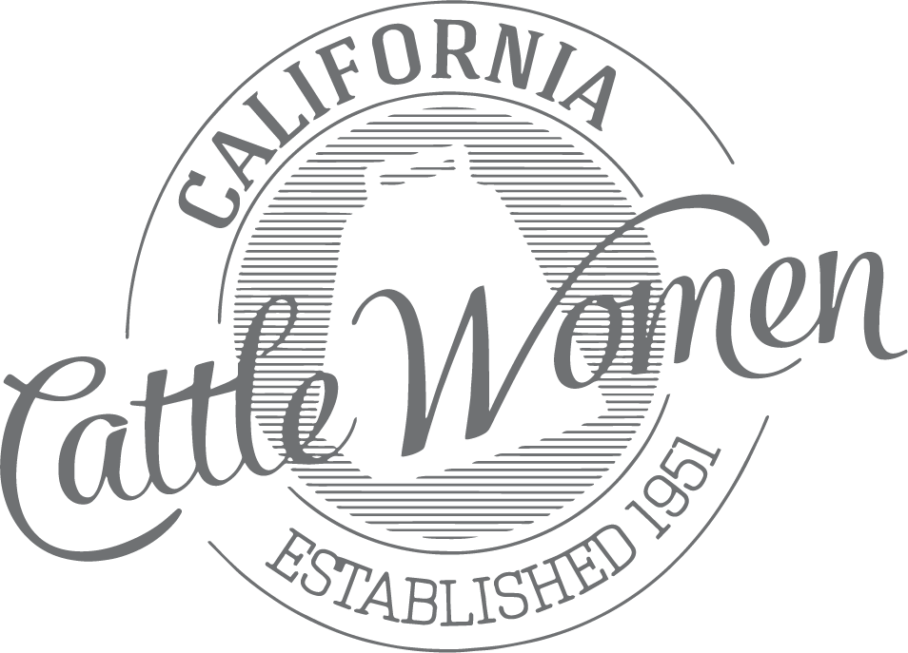
Spring Meeting
March 13-15,2026
Fairfield Inn & Suites Winters Davis
702 Matsumoto Lane Winters, CA 95694
530-240-3200 Group rate, $139 king room per night, $149 double queen, under California CattleWomen, February 13 is room reservation deadline
Room booking link:
https://www.marriott.com/event-reservations/reservation-link.mi?id=1752869470154&key=GRP&app=resvlink

Friday, March 13
2-3:30 Tour of Monsanto in Woodland, CA, Pre-registration & consent forms required
4:30 pm – 6:30 California CattleWomen Executive Board Meeting
6:30 pm – Reception

Saturday, March 14th

7:30-8:00 Check-In
8:00 Meeting Begins

Highlights of the Day
Ag In the Classroom Lesson Plan
California Beef Council – Food and Nutrition
Program by Beef Promotion and Ag in the Classroom
The Heritage Foundation Meeting
Tour local Almond orchard with farmer - weather dependent

Dinner
Turkovich Winery
30471 Buckeye Road
Winters, CA 95694

Sunday, March 15th
7am Breakfast
7:45- 8:00 am Check-In for CattleWomen Board of Directors Meeting
8:00 am California CattleWomen Board of Directors Meeting
10:30- 12:00 pm Member Information Session

Beef Promotion orders date to be confirmed in email at later date.

California CattleWomen
Spring Meeting
March 13-15,2026

Registration:

Registration is due with payment!!!!! It is pre-ferred that you pre-register.
Both online and in person registration is due by Sunday, March 1.

Online Registration is $25.00 and just for the Board of Directors meeting, on Sunday, March 15th.
Register by February 14 for early registration, increases by $10 after to
Callie Martinez 9337 Campbell Road Winters, CA 95694 530-526-3070 callie.borror@yahoo.com

Name: ____________________________________________________________________________
___ County President ___ Delegate_____State Executive Board _____ State Committee Chair

Address: __________________________________________________________________________
City:__________________Zip:______________ Phone:_____________________________________
Food Allergies:________________________________________________________

___________ Tour of Monsanto in Woodland. Deadline to register is January 31, 2026
All inclusive registration includes:
Meeting on Saturday with lunch, Dinner & Charcuterie Activity at Winery, Drone Tour as Yolo Land and Cattle, and Almond Orchard Talk and Bus Transportation_____x $200.00 = __________
Lunch only on Saturday ___________x $40.00= ___________
Late Registration after February 14th $210.00 ___ x $ ____________
Total Cost $_____________

California CattleWomen
Spring Meeting
Saturday, March 14, 2026
7:00 am Breakfast on own at hotel
8:00 am Welcome
8:15 am Heritage Board Meeting
9:15 am Danika Kester
10 Tehama County CattleWomen present Crockpot Project
10:45 – 11 am break
11-11:45 am CA Beef Council
12- 1 pm Lunch
1-1:45 pm California Ag in the Classroom Presentation
3 pm Region VI Meeting Planning Check-In
3:30 pm Depart for Zipline Tour at Yolo Land and Cattle, tour Almond Orchard
5pm – 8:15 pm Turkovich Winery

