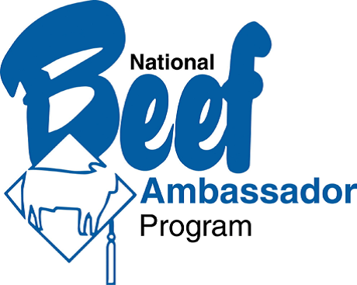
Angelee Dowling
From Siskiyou County Wins the
National Junior Beef Ambassador Contest

Angelee Dowling from Siskiyou County and Abby Grisedale from Kern County represented California at the National Beef Ambassador Contest in Denver. The contest is put on by American National CattleWomen. Sixteen-year-old Angelee Dowling was chosen as the winner of the junior division earning her the title of National Junior Beef Ambassador.
There were thirty-two contestants in all: nine juniors and twenty-three seniors. Both of the California girls did an outstanding job. Jill Bright, chairwoman of the California Beef Ambassador Contest, and the contestants’ mothers, Christina Dowling and Kellie Grisedale, accompanied the girls.
There were four segments to the competition: issues response, education and outreach, consumer demonstration, and media interview. Of the senior contestants, five were chosen to be on the National Beef Ambassador Team; they are
Mackenzie Kimbro - Arizona, Lauren Schlothauer - New Mexico, Hannah Nave - Tennessee, Ashytn Shrewsbury - Nebraska and Kylee Sigmon - Arkansas.
California is so proud of Abby and Angelee. Both of these young ladies trained hard and put in a lot of hours preparing for this national competition. We look forward to them representing the beef industry in the months and years ahead. Once a Beef Ambassador always a Beef Ambassador!
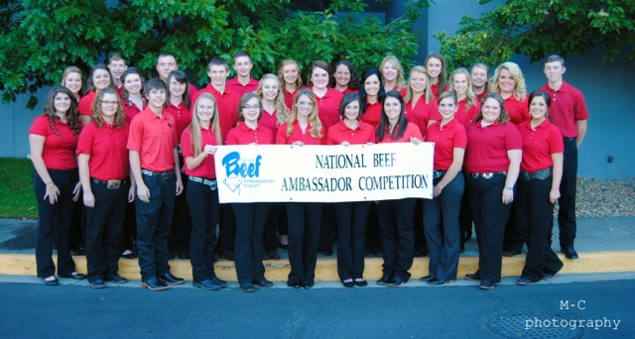
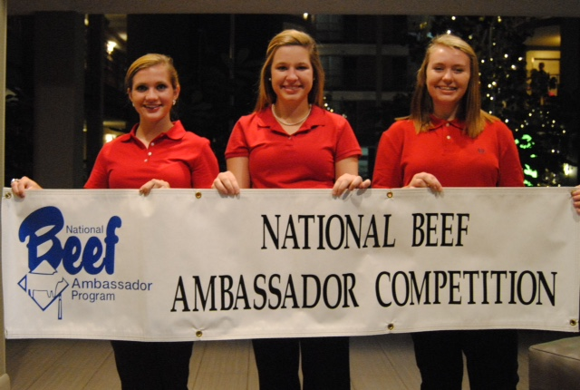
All BEEF Ambassador Contestants at the
National Contest in Denver, Colorado

